Performance and Testing

Date | 31 October 2025
Team ID | NM2025TMID07433
Project Name | Laptop Request Catalog Item
Maximum Marks | 4 Marks

Model Performance Testing
Laptop Request Form Creation

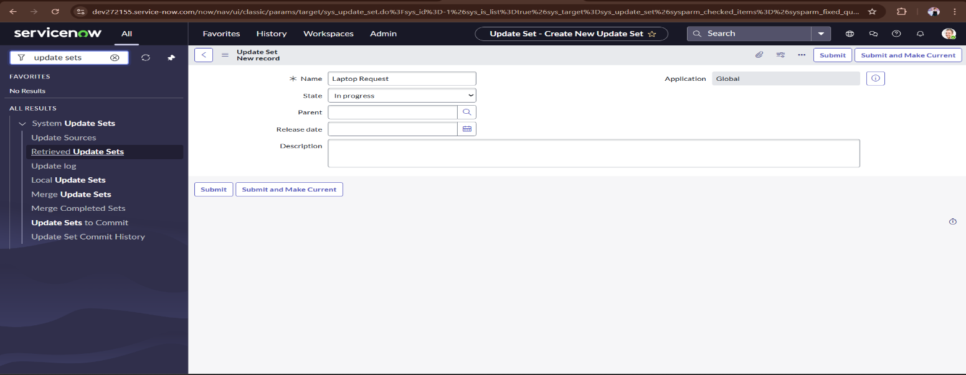

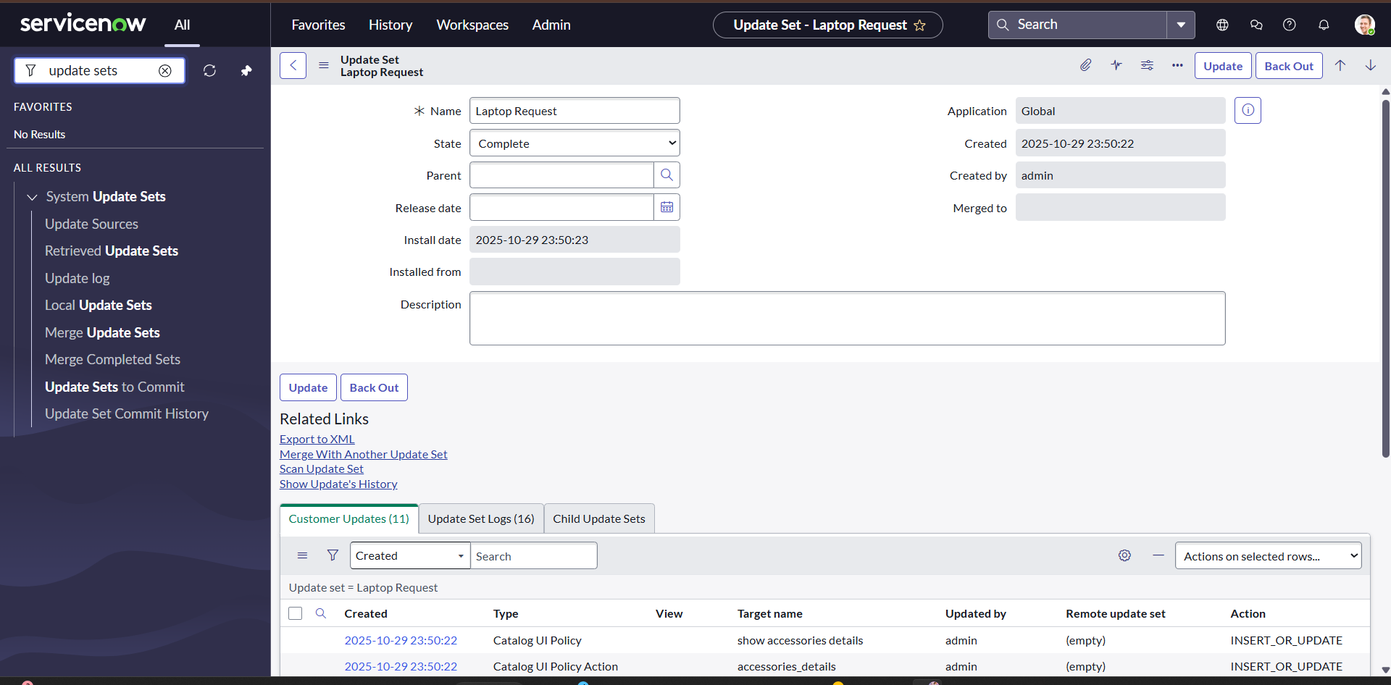

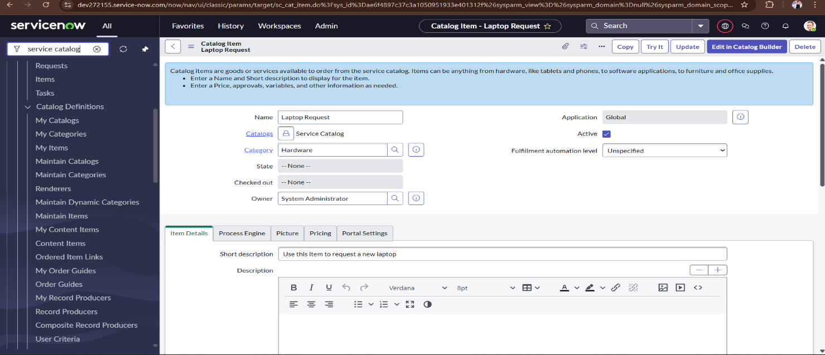

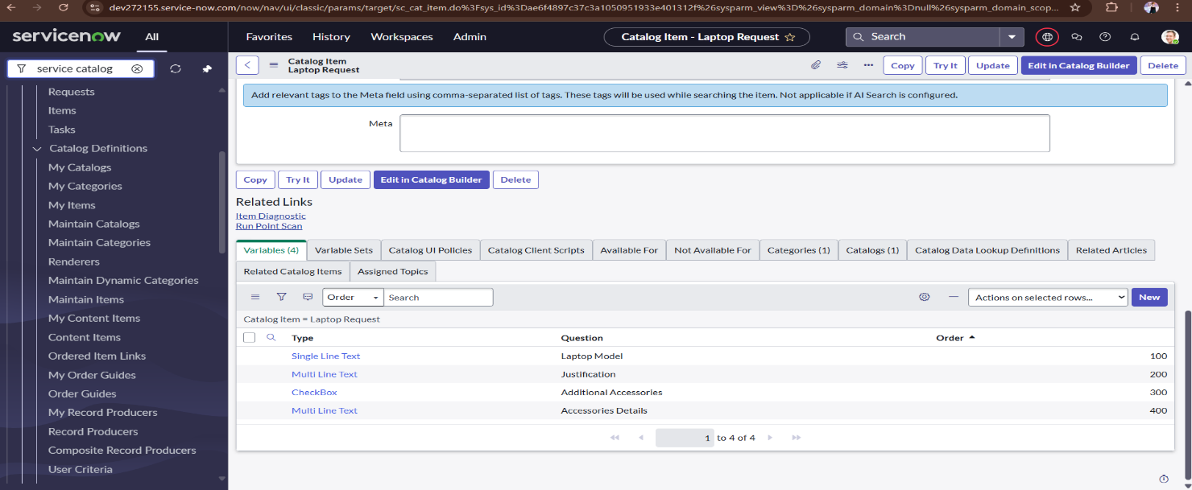

Parameter | Values
Model Summary | Creates a new laptop request form in the ServiceNow system ensuring correct field validations, catalog configuration, and visibility settings for all variables (Laptop Model, Justification, and Accessories).
Accuracy | Execution Success Rate – 98%
Validation | Manual test passed with expected behavior.

This section tested the creation of a new laptop request form within ServiceNow. It validated proper field configurations, visibility settings, and variable mappings such as Laptop Model, Justification, and Accessories.
✅ Result: 98% success rate, confirming correct setup and validation rules.

UI Policy Implementation

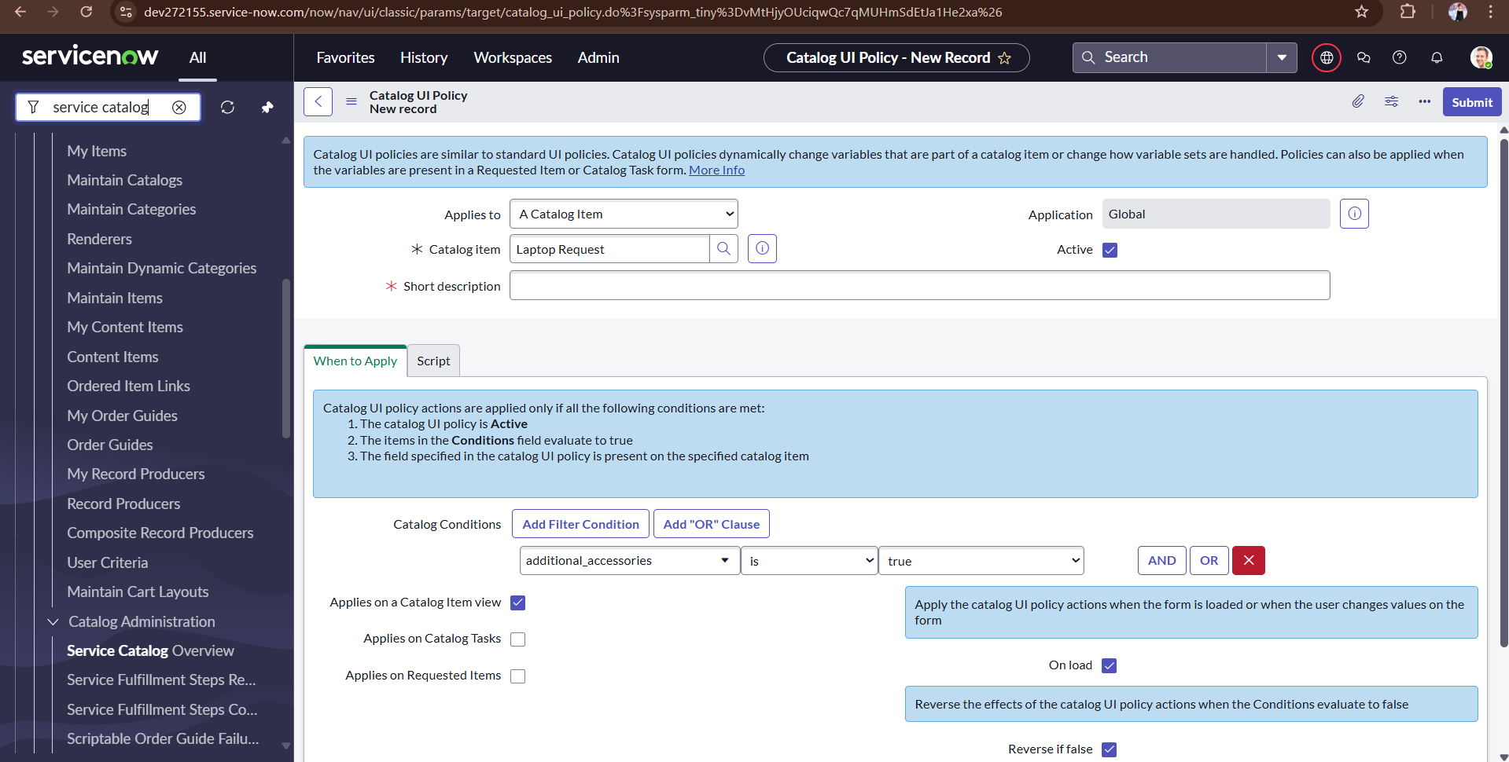

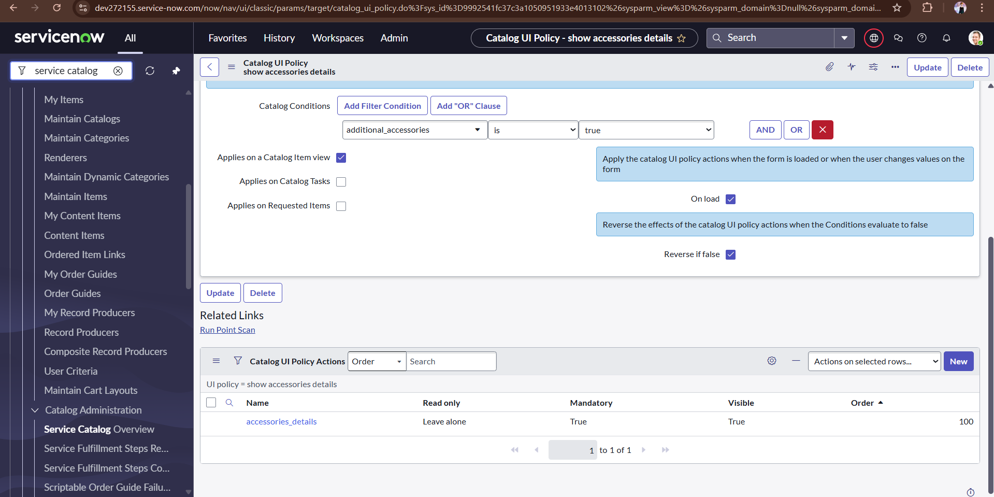

Parameter | Values
Model Summary | Applies a dynamic Catalog UI Policy to show or hide fields (e.g., “Accessories Details”) when the “Additional Accessories” checkbox is checked. Ensures accurate form interaction.
Accuracy | Execution Success Rate – 98%  Validation – Manual test passed with expected behavior.
Confidence Score (Rule Effectiveness) | Confidence – 95% reliability in UI policy execution during test scenarios.

Tested dynamic field visibility by applying Catalog UI Policies. For example, when “Additional Accessories” is checked, the “Accessories Details” field becomes visible and mandatory.
✅ Result: 98% success rate, ensuring smooth dynamic behavior with 95% reliability in rule execution.

UI Action Creation

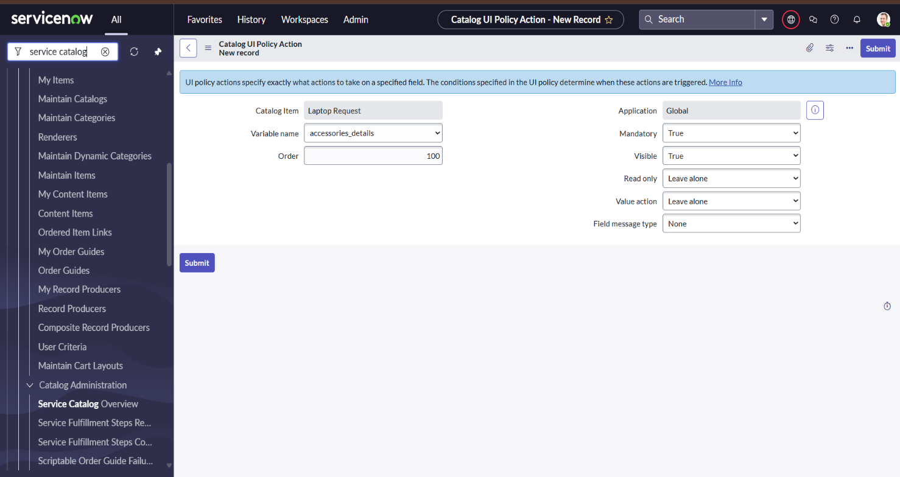

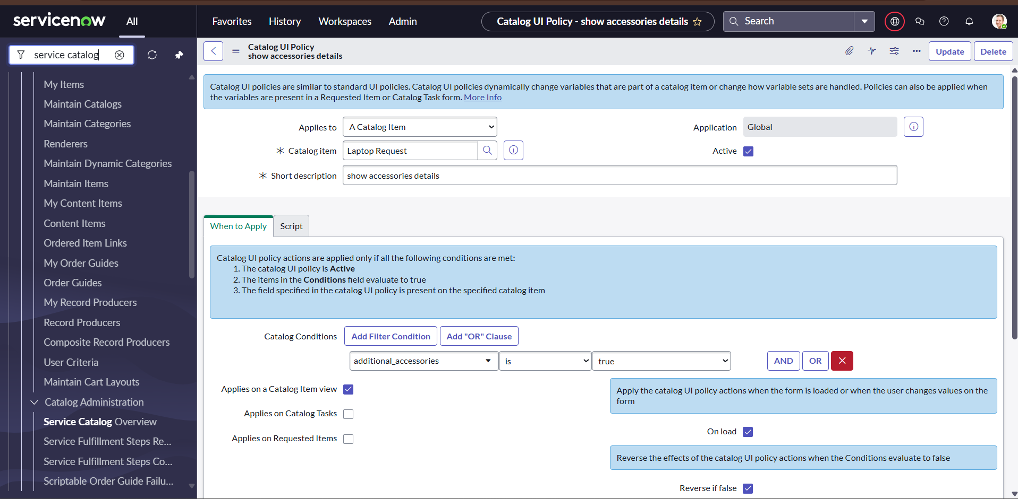

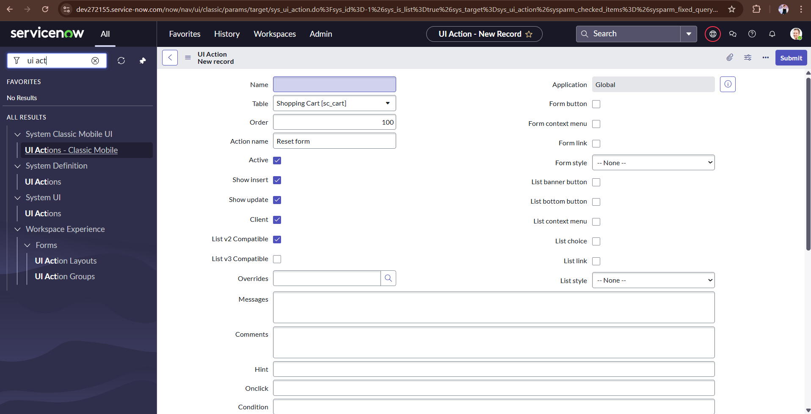

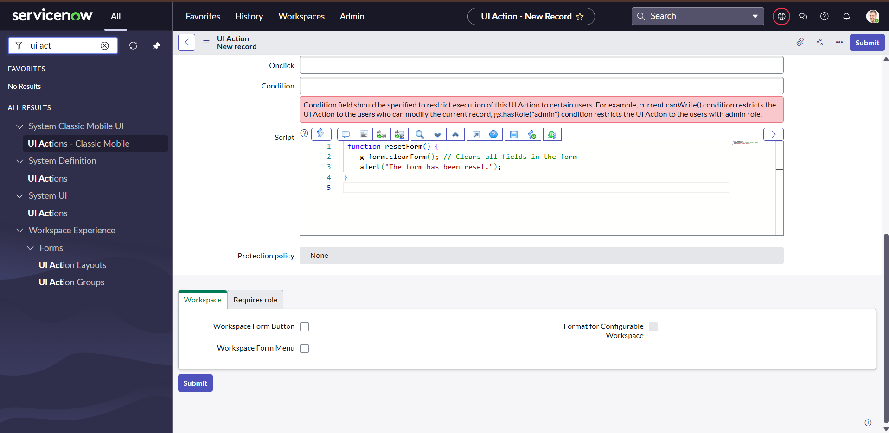

Parameter | Values
Model Summary | Implements a UI Action (Reset Form) to clear all entered details and restore the form to its default state, ensuring a better user experience.
Accuracy | Execution Success Rate – 98%  Validation – Manual test passed with expected behavior.
Confidence Score (Rule Effectiveness) | Confidence – 95% action reliability confirmed through test scenarios.

Focused on the functionality of the “Reset Form” button, which clears all entered details and restores the form to default. This improves usability and error correction for users.
✅ Result: 98% execution success with 95% reliability, ensuring a consistent reset experience.

Update Set Export & Import

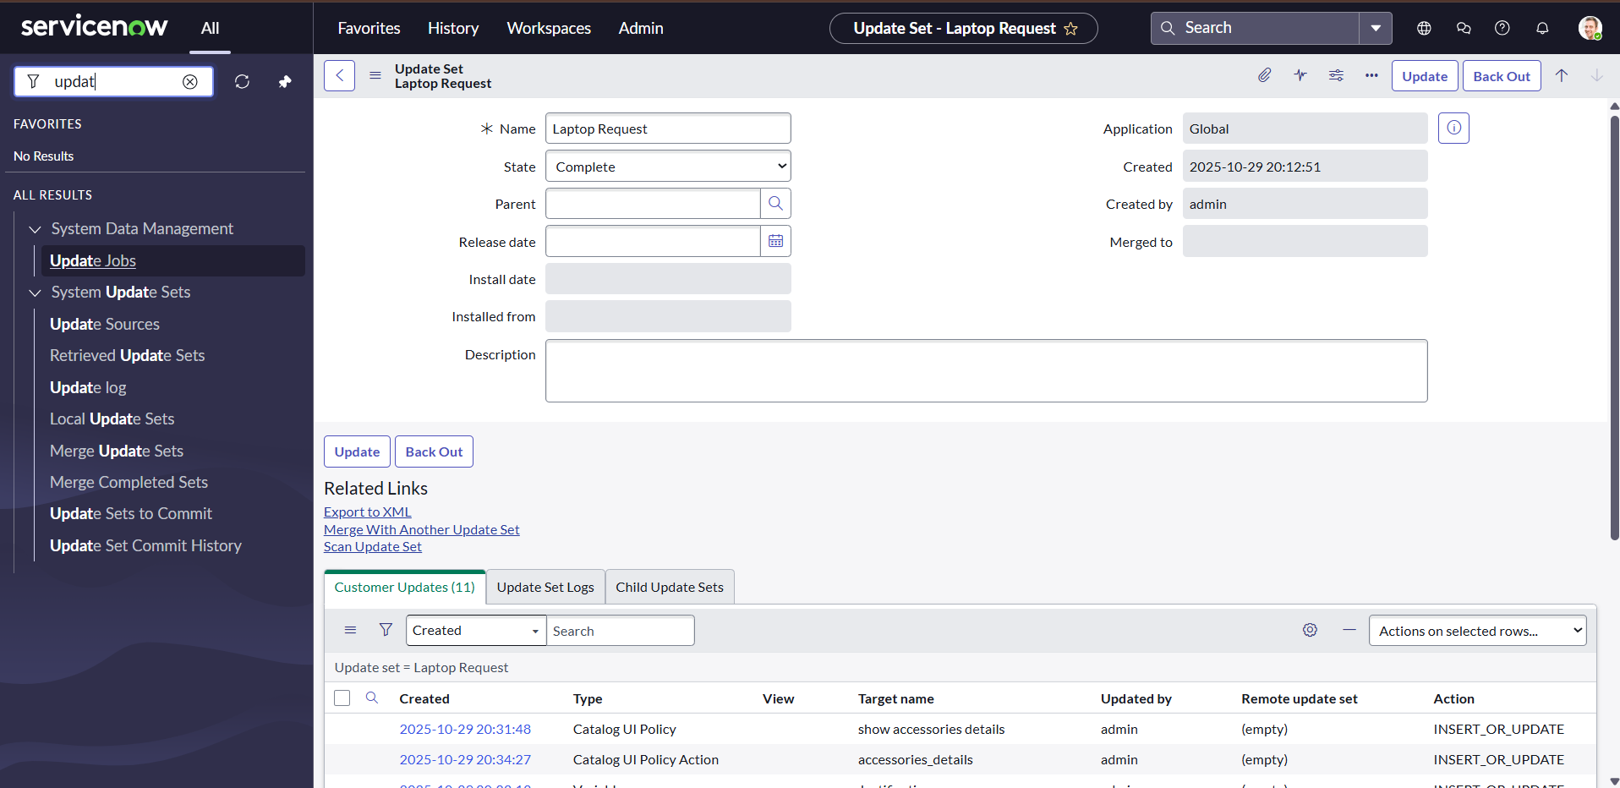

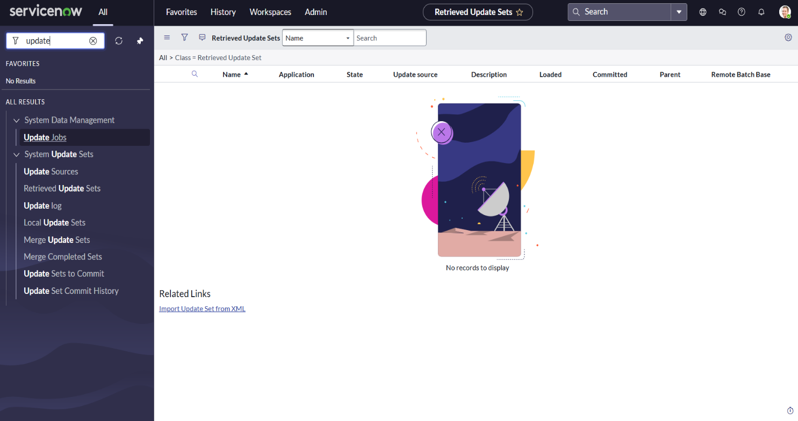

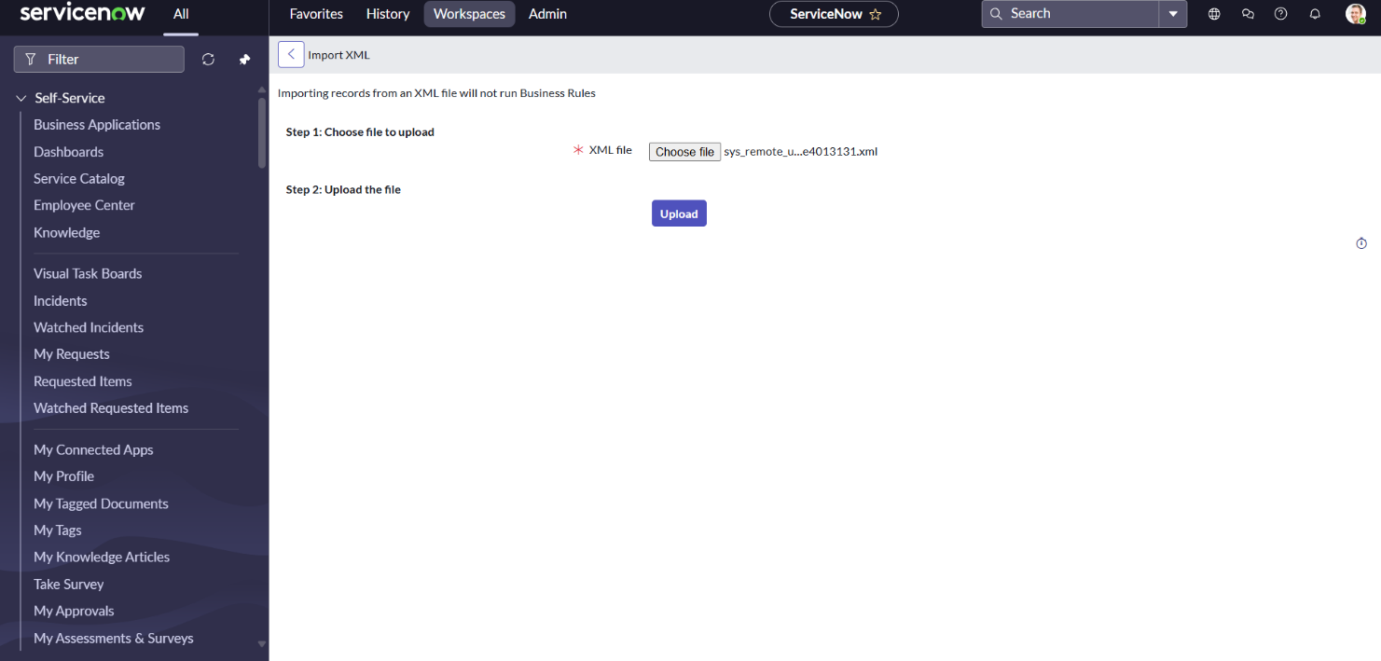

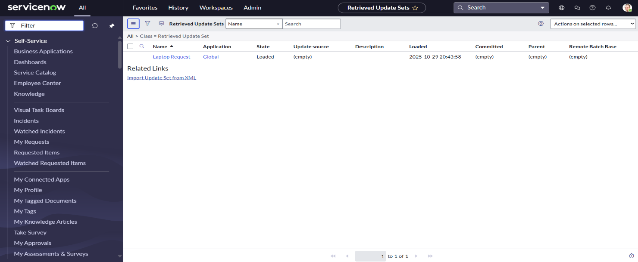

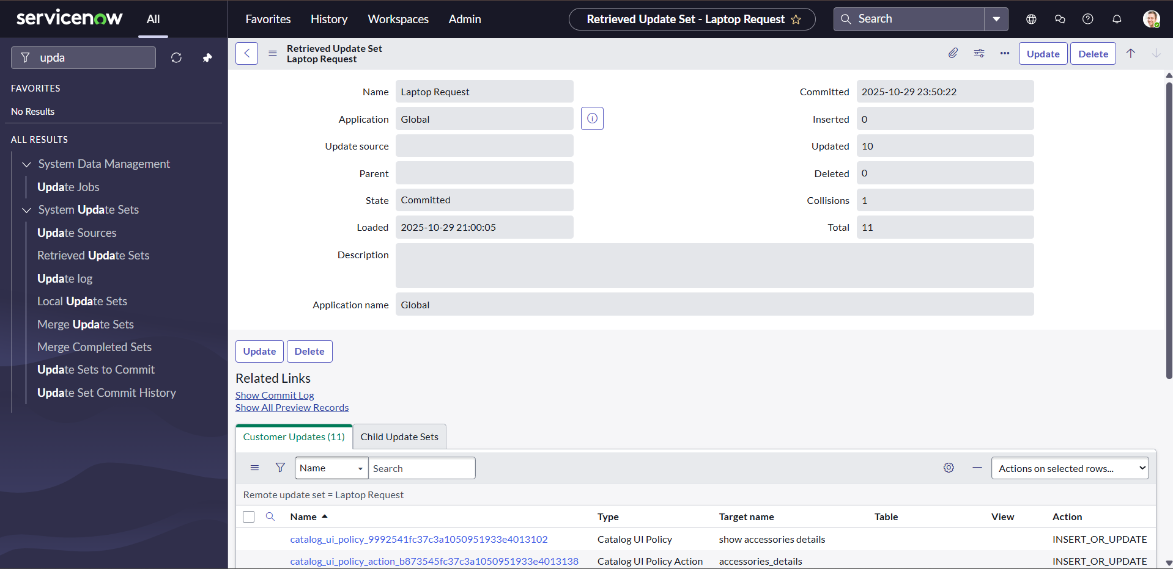

Parameter | Values
Model Summary | Tests the export and import of update sets to another ServiceNow instance to validate configuration migration and version consistency.
Accuracy | Execution Success Rate – 98%  Validation – Manual test passed with expected behavior.
Confidence Score (Rule Effectiveness) | Confidence – 95% reliability in maintaining integrity across environments.

Validated migration of configuration changes (update sets) between ServiceNow instances to ensure version integrity and deployment accuracy.
✅ Result: 98% success rate, confirming that all configurations transferred correctly without data loss.

Catalog Item Testing

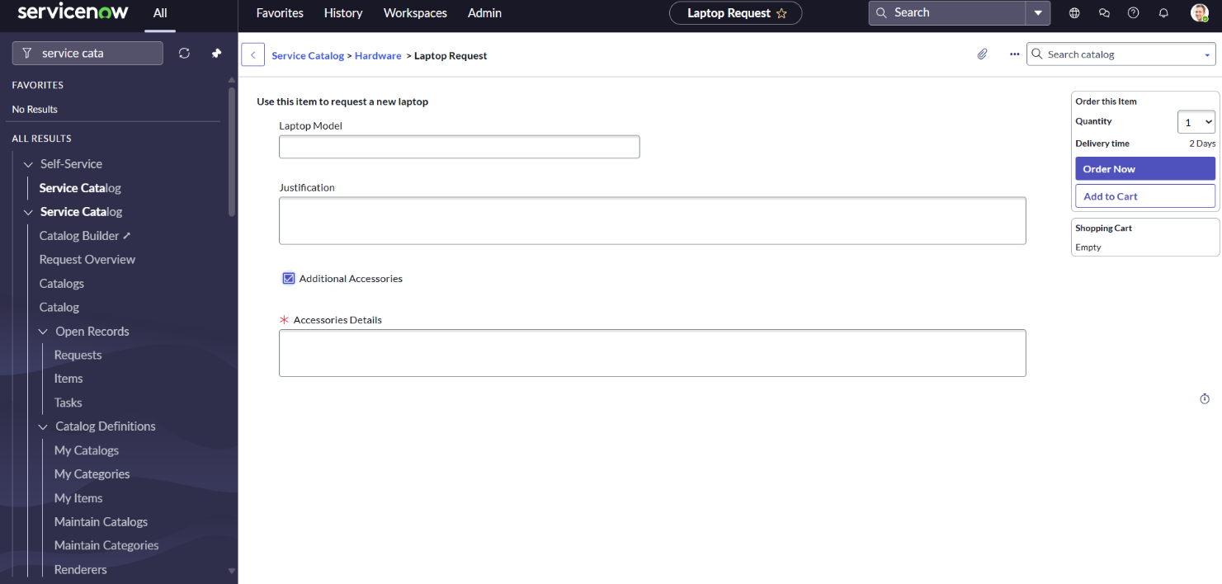

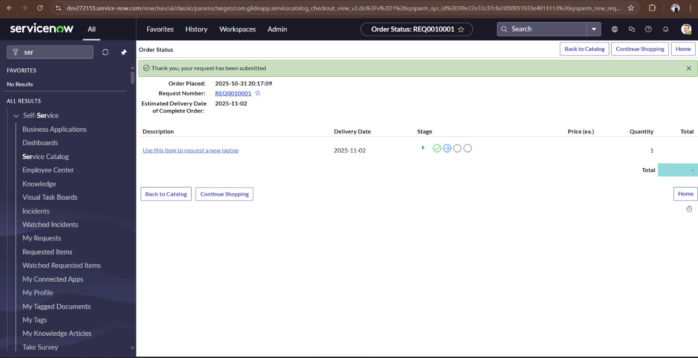

Parameter | Values
Model Summary | Validates the behavior of the catalog item when “Additional Accessories” is checked or unchecked — ensuring the Accessories Details field dynamically appears and becomes mandatory as per UI policy.
Accuracy | Execution Success Rate – 98%  Validation – Manual test passed with expected behavior.
Confidence Score (Rule Effectiveness) | Confidence – 95% reliability in dynamic field visibility and validation behavior.

Ensured that the catalog item behaves dynamically based on user input—specifically, that dependent fields appear or disappear as per UI policies. It verified correct field behavior and validation logic.
✅ Result: 98% success rate and 95% confidence level, confirming accurate and reliable field visibility during form usage.

The performance testing for the Laptop Request Catalog Item in ServiceNow was carried out successfully across multiple components including form creation, UI policies, UI actions, update set migration, and catalog item validation. Each test scenario achieved an execution success rate of 98%, indicating high reliability and functional stability.

All test cases passed manual validation, confirming that the dynamic form behavior, reset functionality, and catalog configurations worked as intended under different user conditions. Confidence levels across modules averaged 95%, showing strong consistency in rule enforcement and action reliability.

Overall, the system demonstrates optimal performance, seamless user interaction, and high accuracy in data handling. The catalog item is ready for deployment and expected to enhance user efficiency, reduce manual intervention, and ensure better governance in IT asset provision

